DRAWING QUADRATIC GRAPHS
Pearson Edexcel - Tuesday 21 May 2019 - Paper 1 (Non-Calculator) Foundation Tier

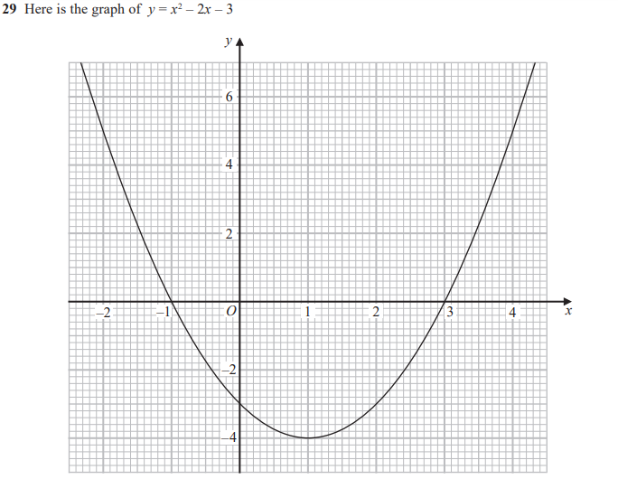
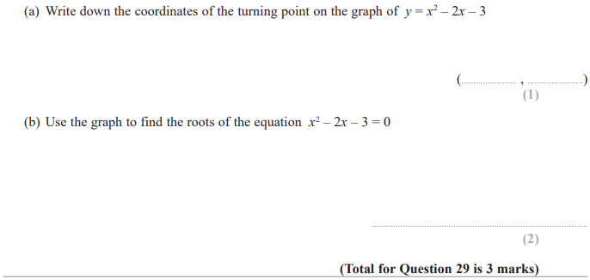
Pearson Edexcel - Monday 12 November 2018 - Paper 3 (Calculator) Foundation Tier

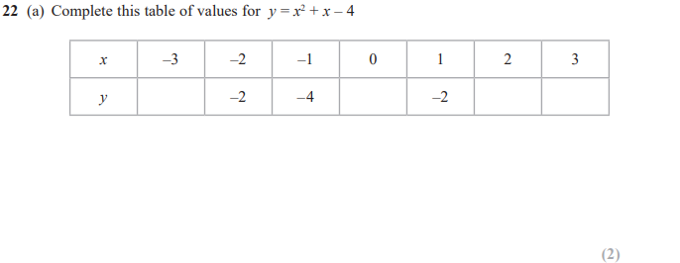
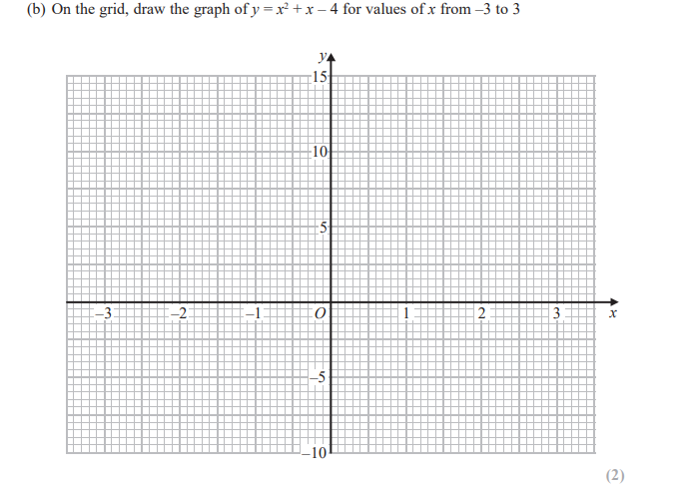
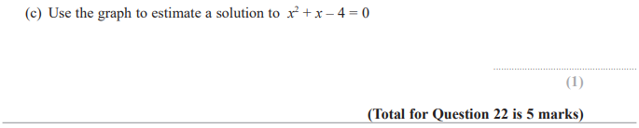
Pearson Edexcel - Thursday 7 June 2018 - Paper 2 (Calculator) Foundation Tier

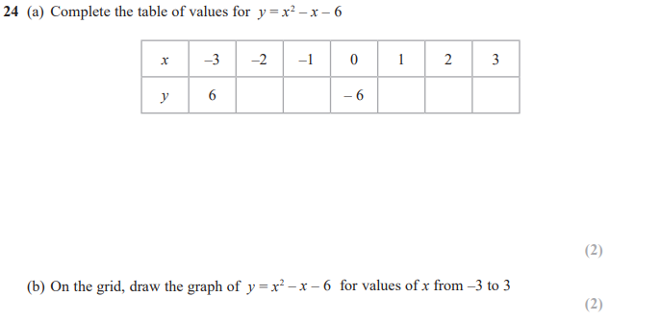
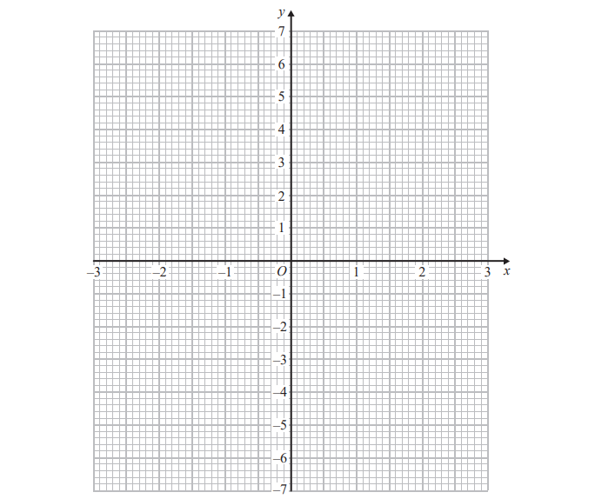
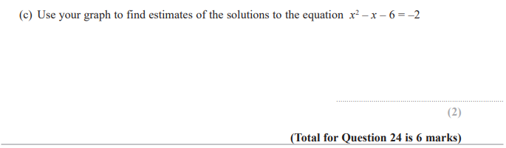

Pearson Edexcel - Thursday 2 November 2017 - Paper 1 (Non-Calculator) Foundation Tier

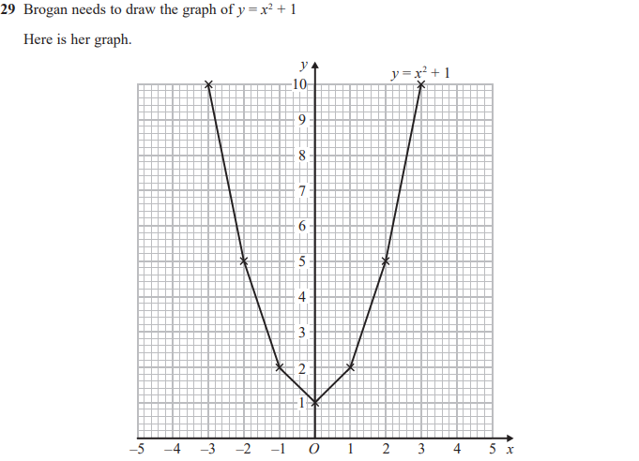

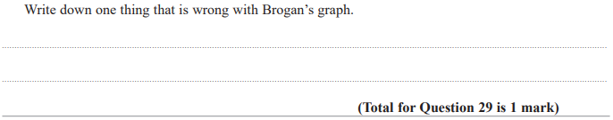

OCR November 09 November 2020- Morning (Calculator) Foundation Tier
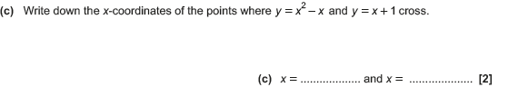
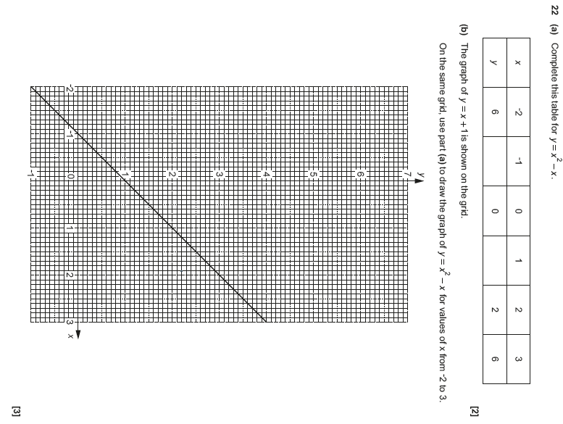

OCR Tuesday 13 June 2017 – Morning (Calculator) Foundation Tier

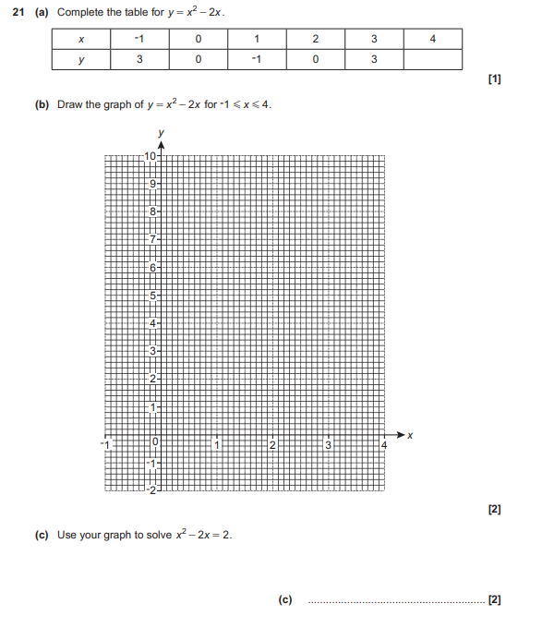

AQA Thursday 4 June 2020 – Morning (Calculator) Foundation Tier

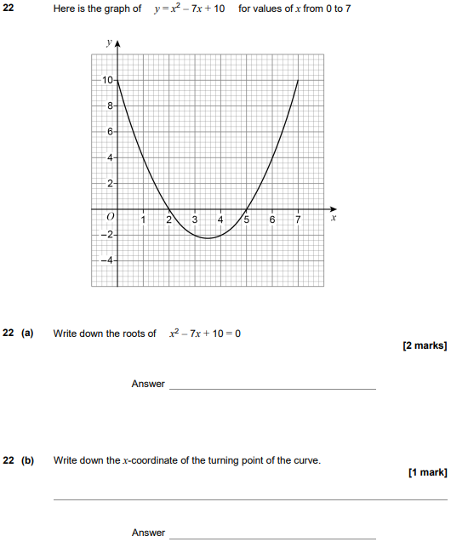

AQA Tuesday 6 November 2018 – Morning (Non-Calculator) Foundation Tier

